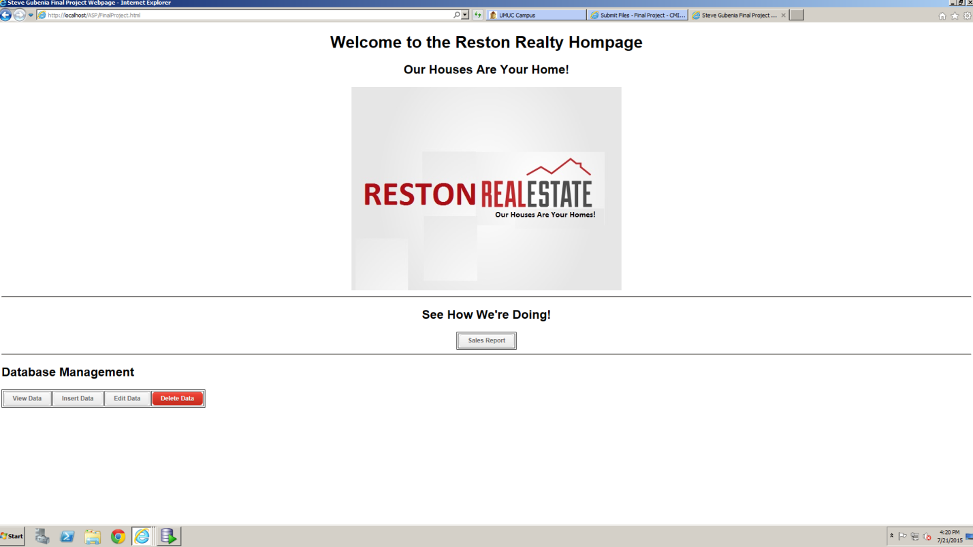

Figure 1 Final Project Hompage

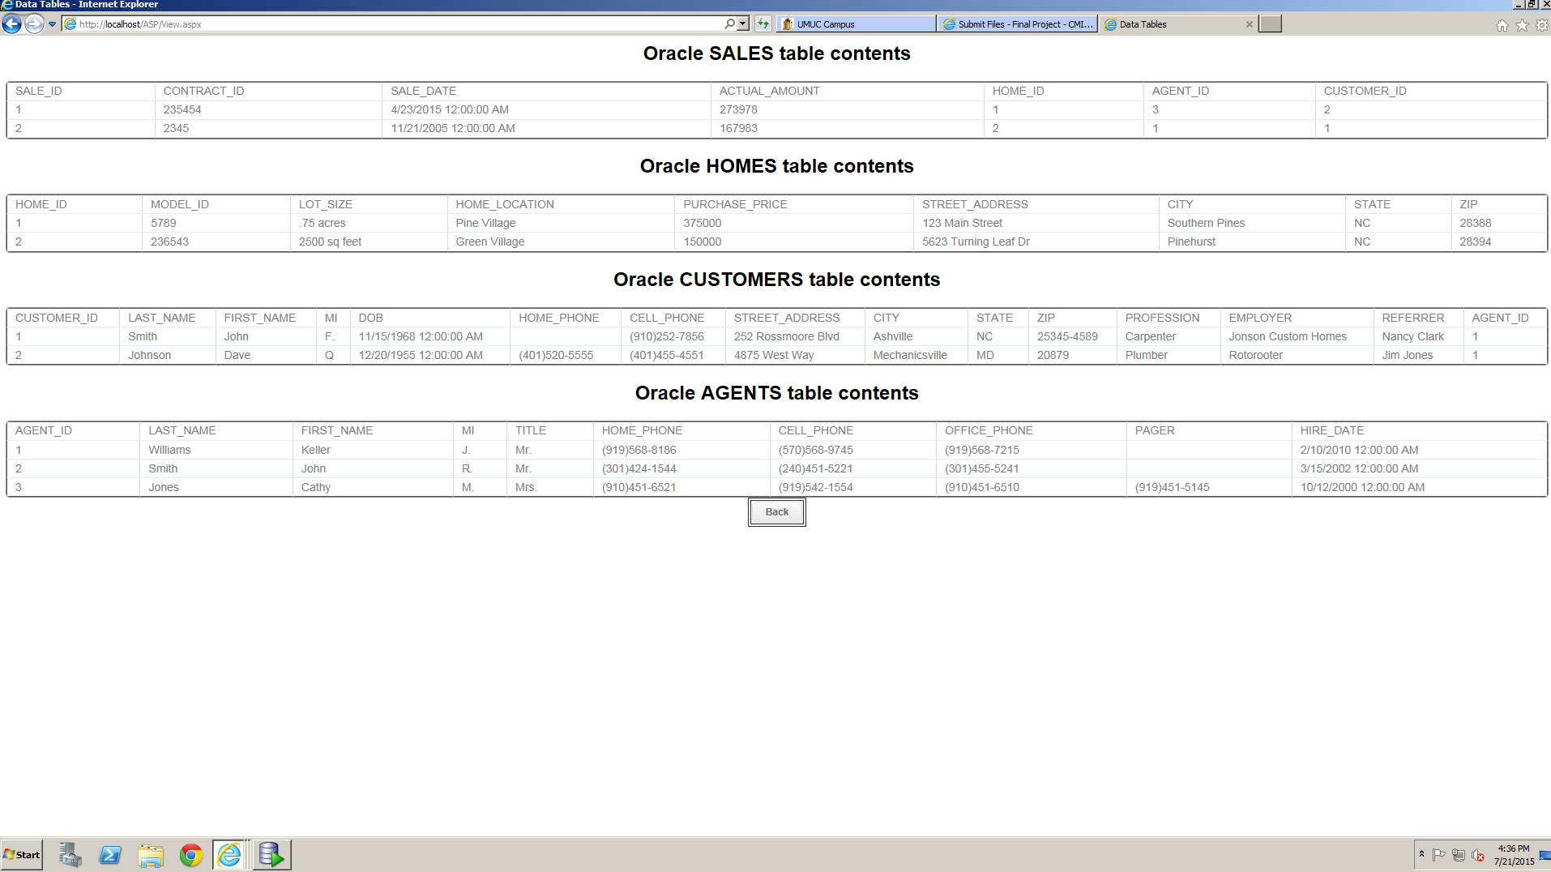

Figure 2 Tables Before Inserts

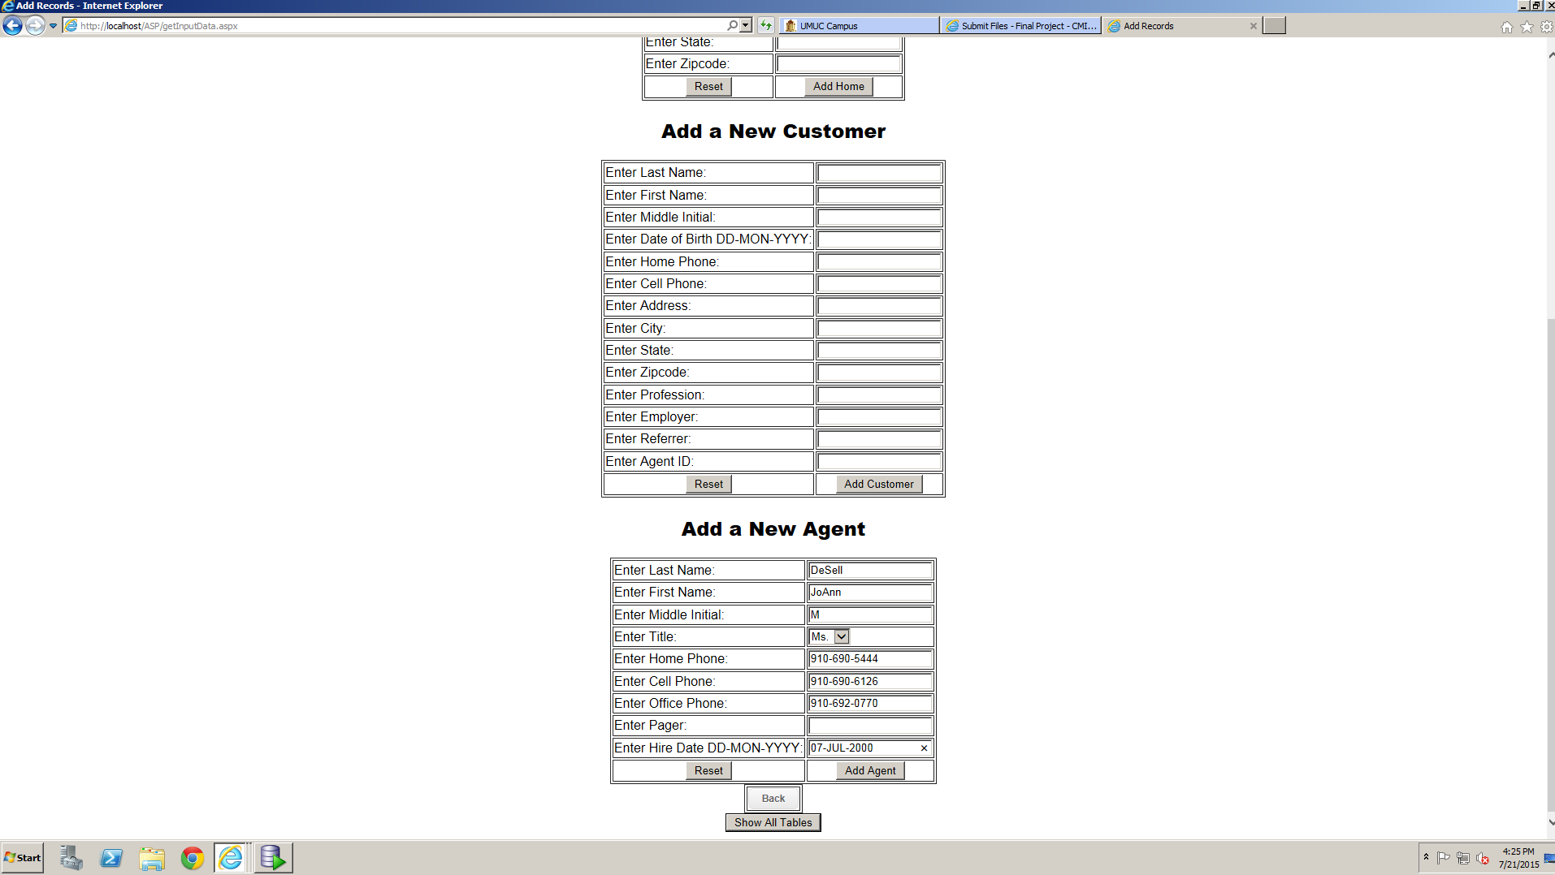

Figure 3 Adding agent

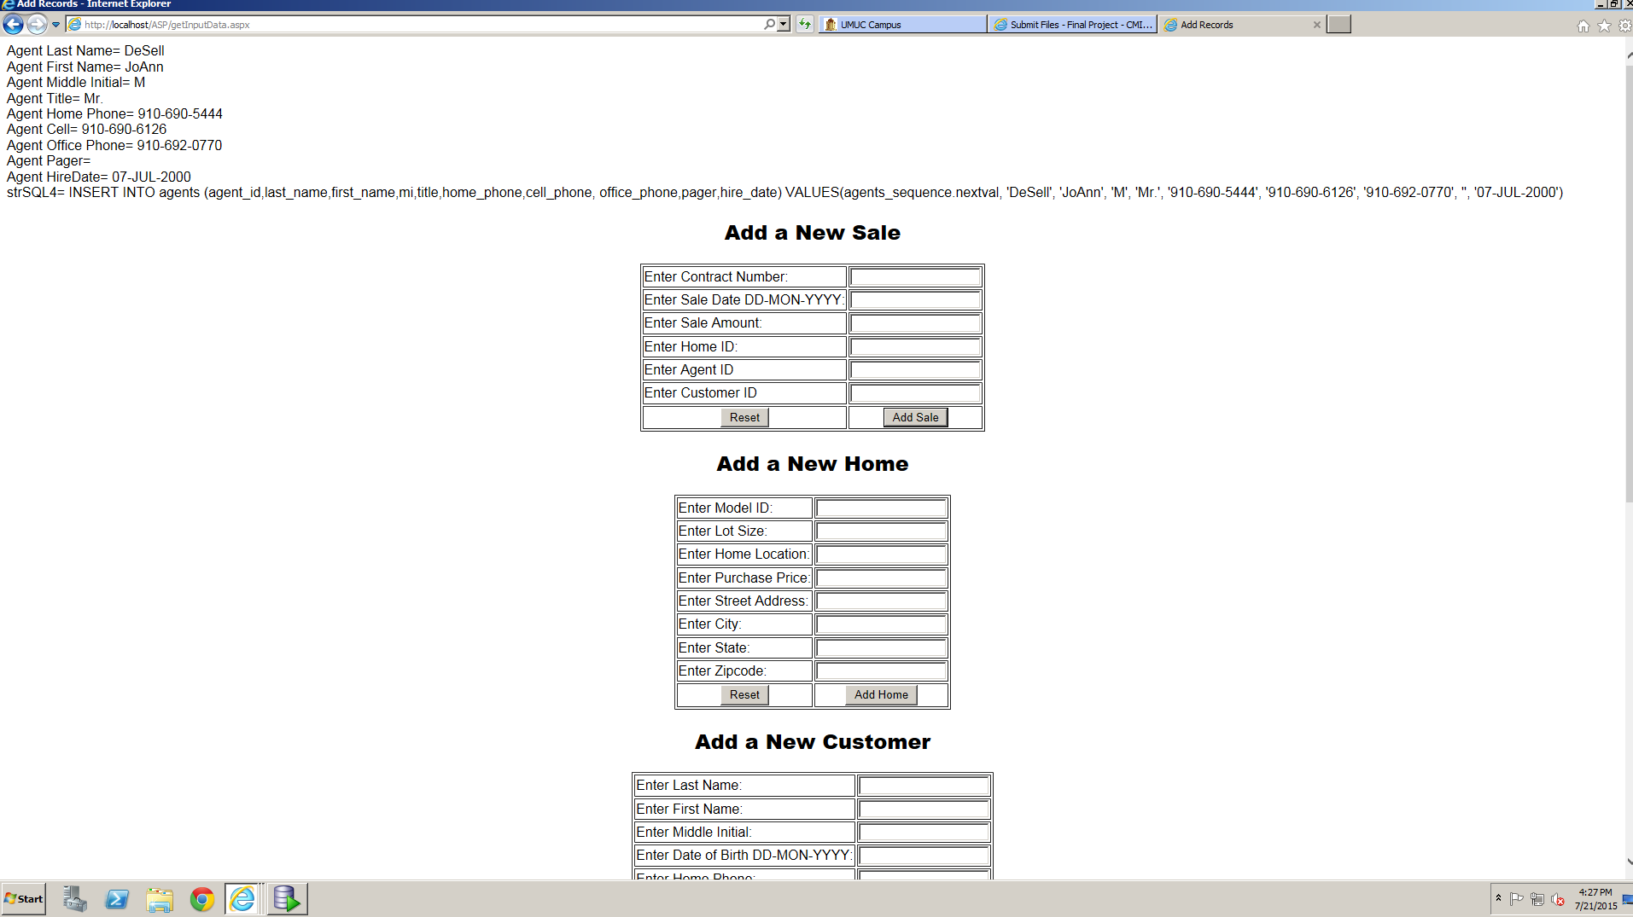

Figure 4 Debugging Statements Successfully displayed for inserting new agent

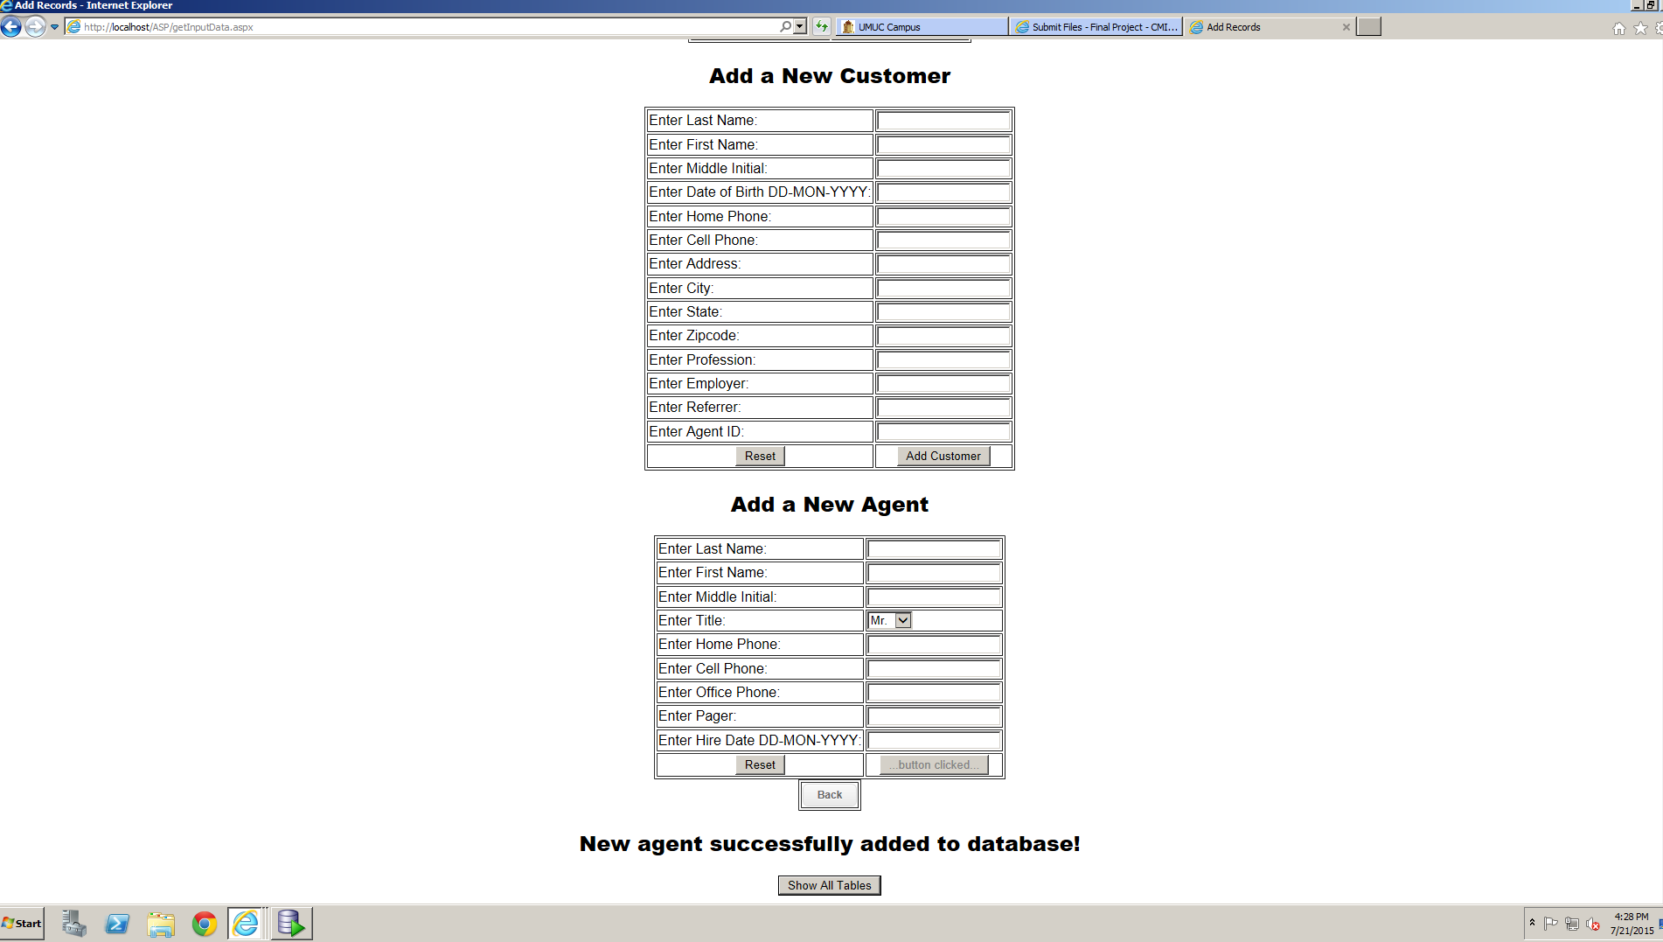

Figure 5 Success message displayed

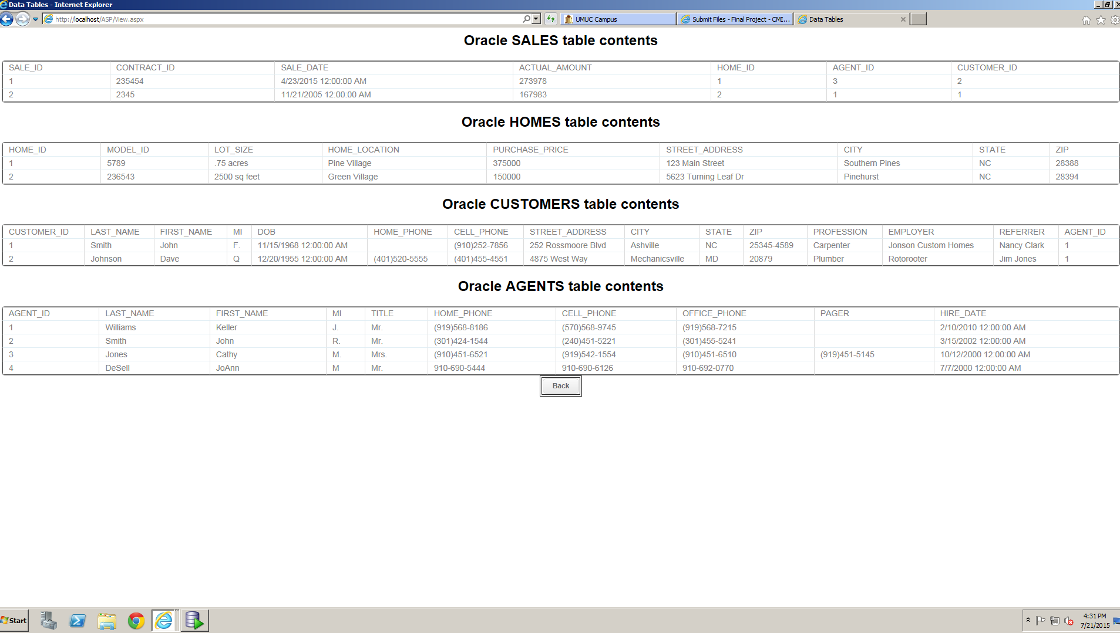

Figure 6 Agent successfully added to table

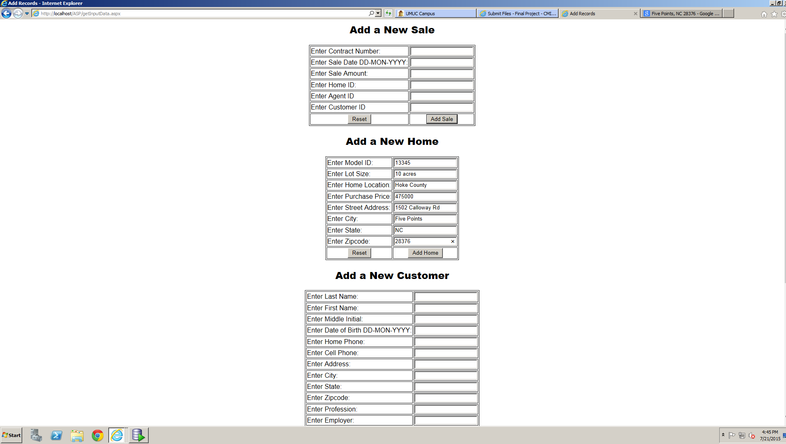

Figure 7 Adding first home

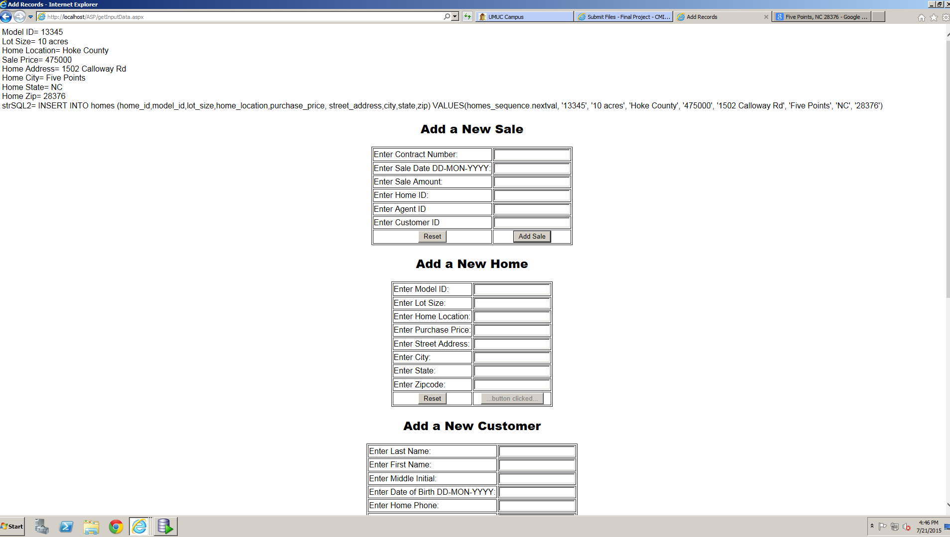

Figure 8 Debugging messages successfully displayed for adding home

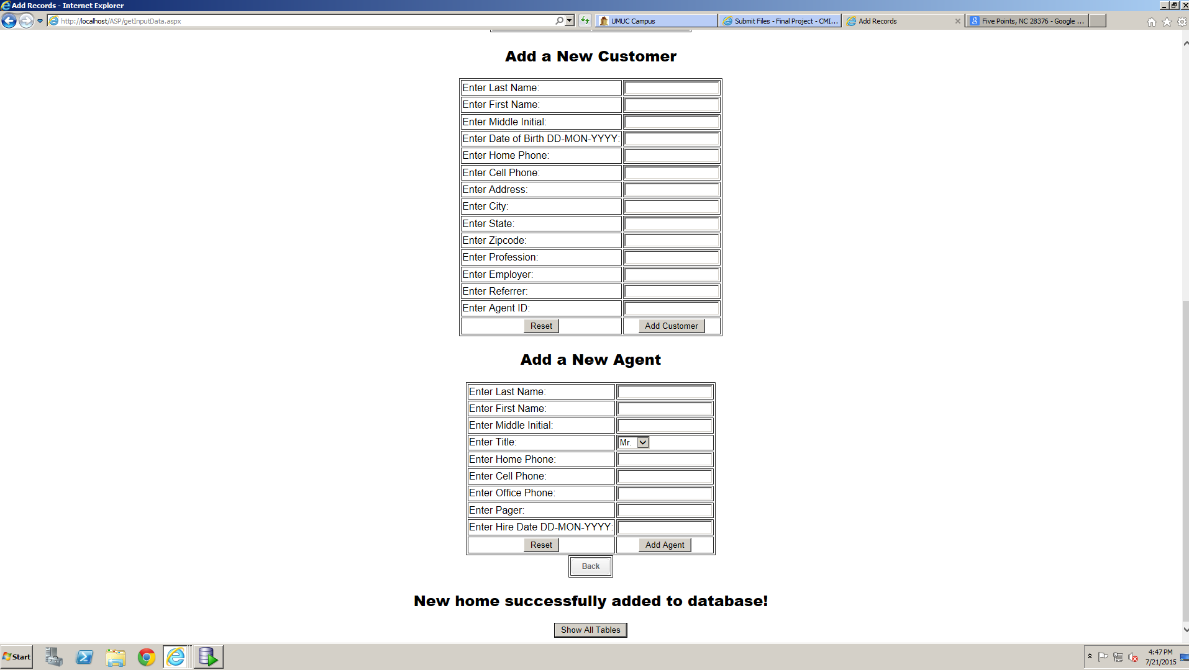

Figure 9 Success message displayed for adding home

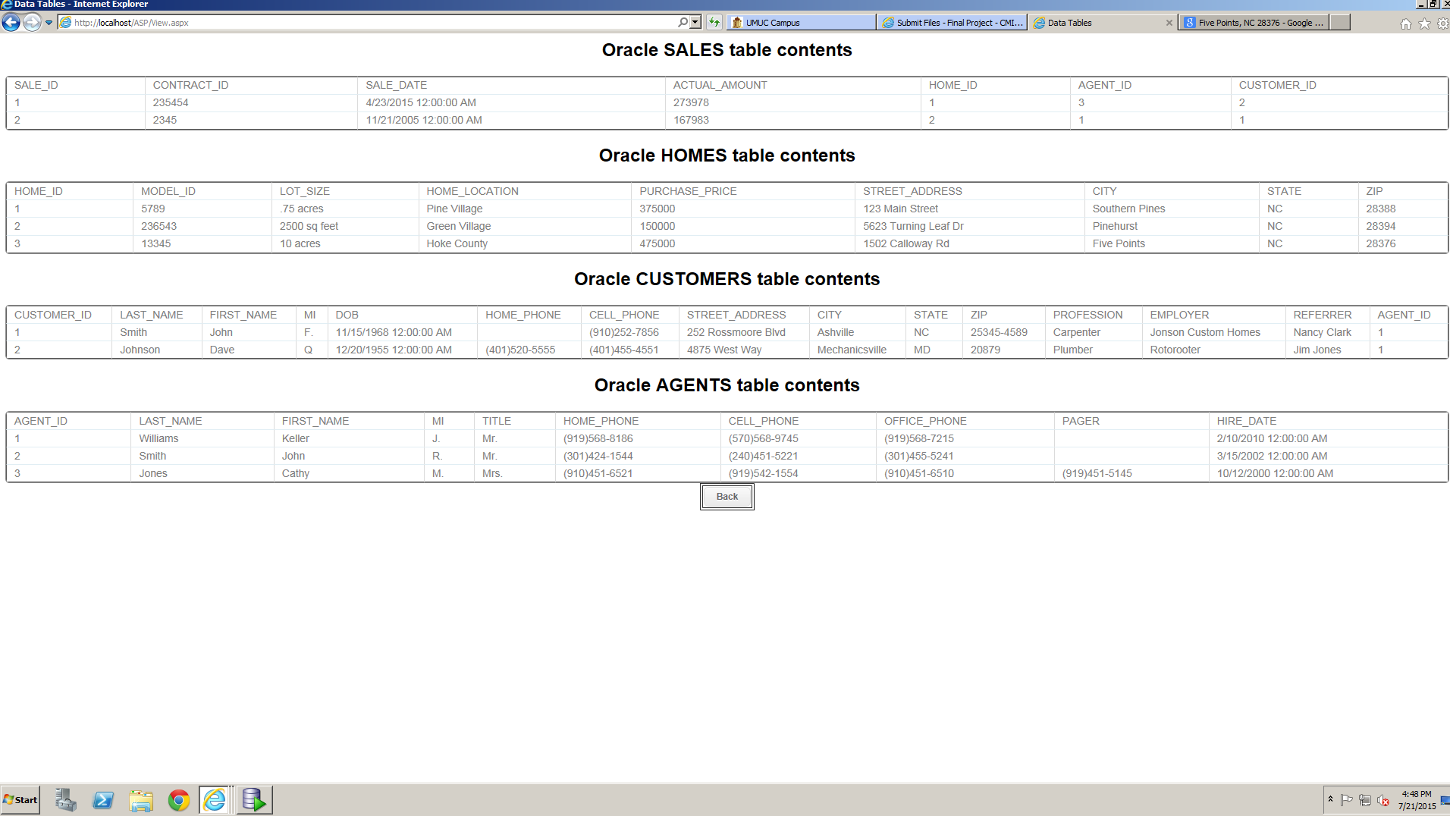

Figure 10 Home successfully added to database

Note: Skipped other debugging and success messages to save space

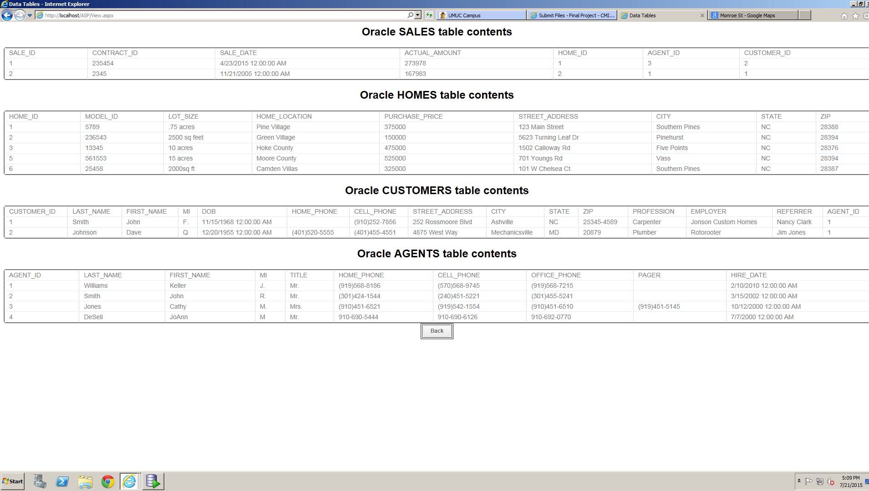

Figure 11 Tables after all 3 homes added

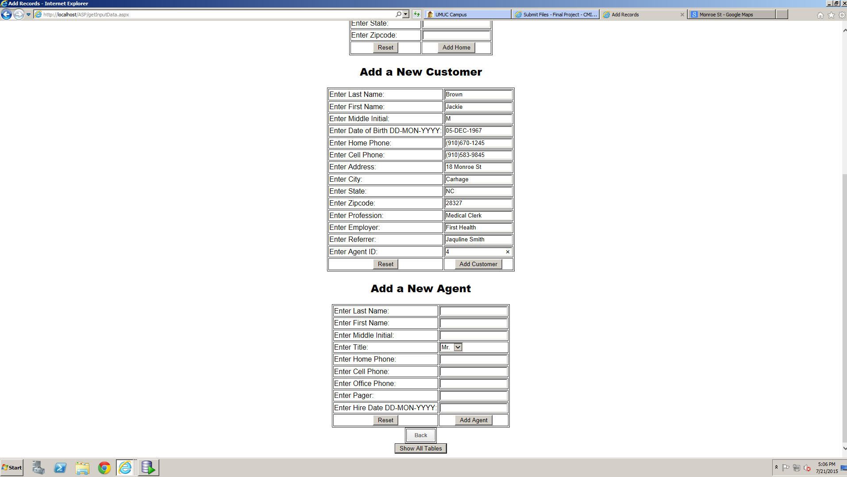

Figure 12 Adding First Customer

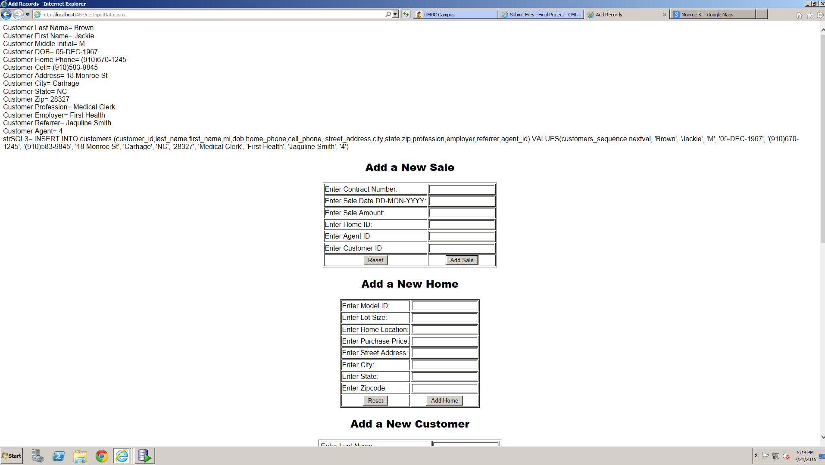

Figure 13 Debugging Statements successfully displayed for adding customer

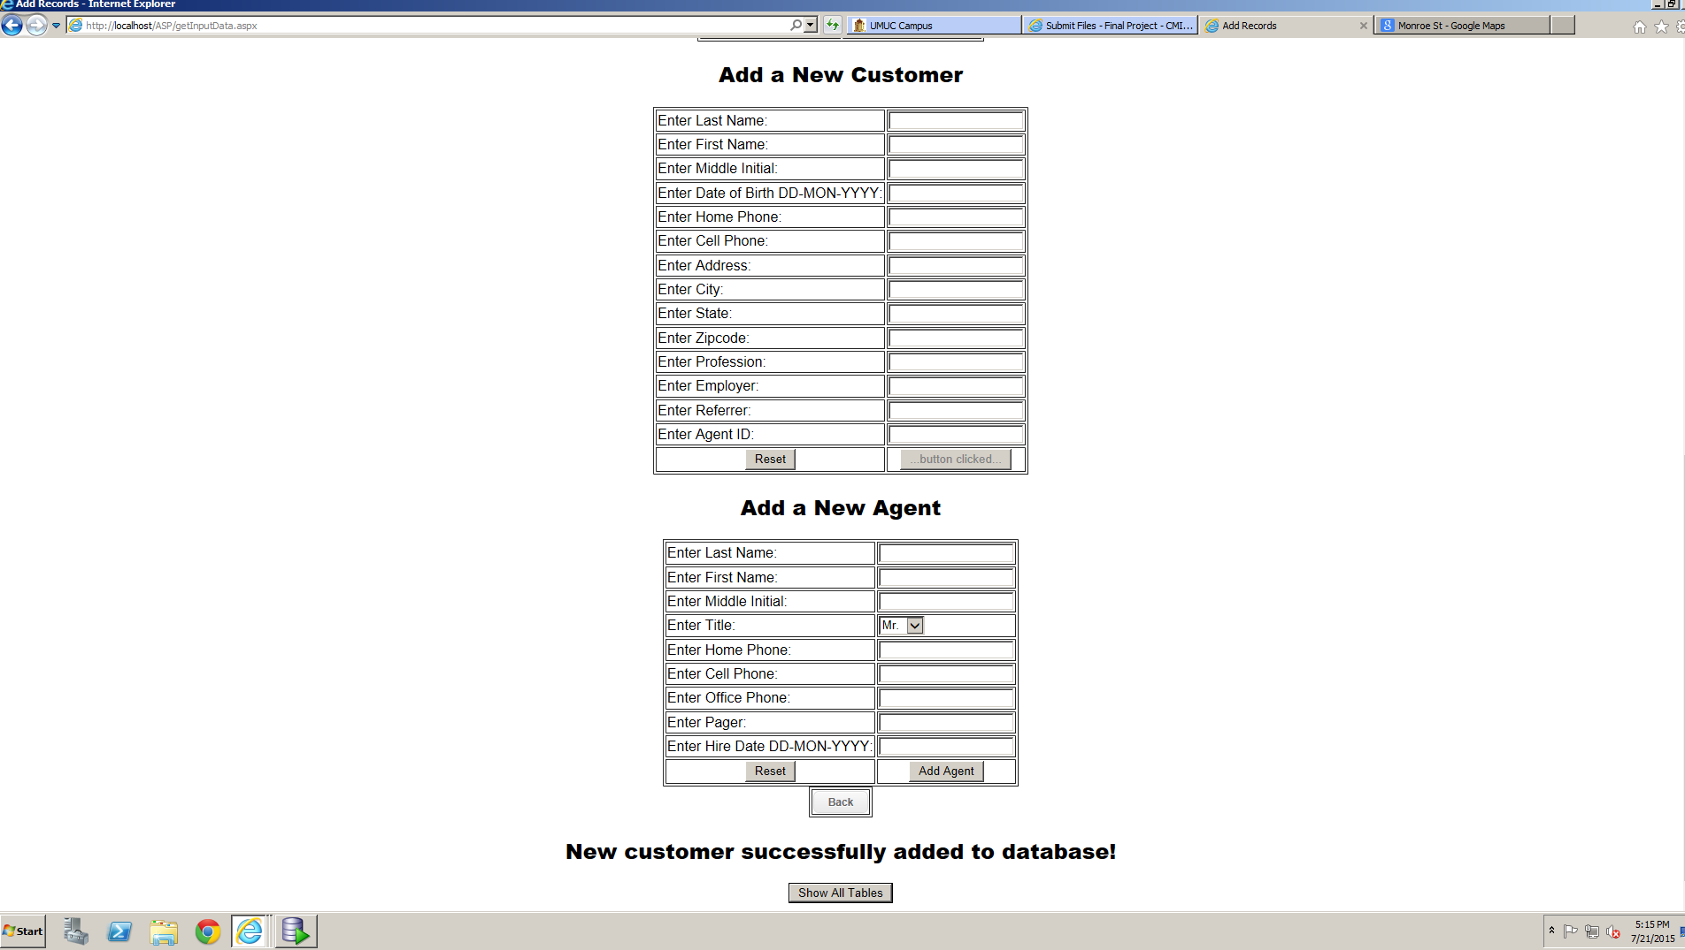

Figure 14 Success Message displayed for adding customer

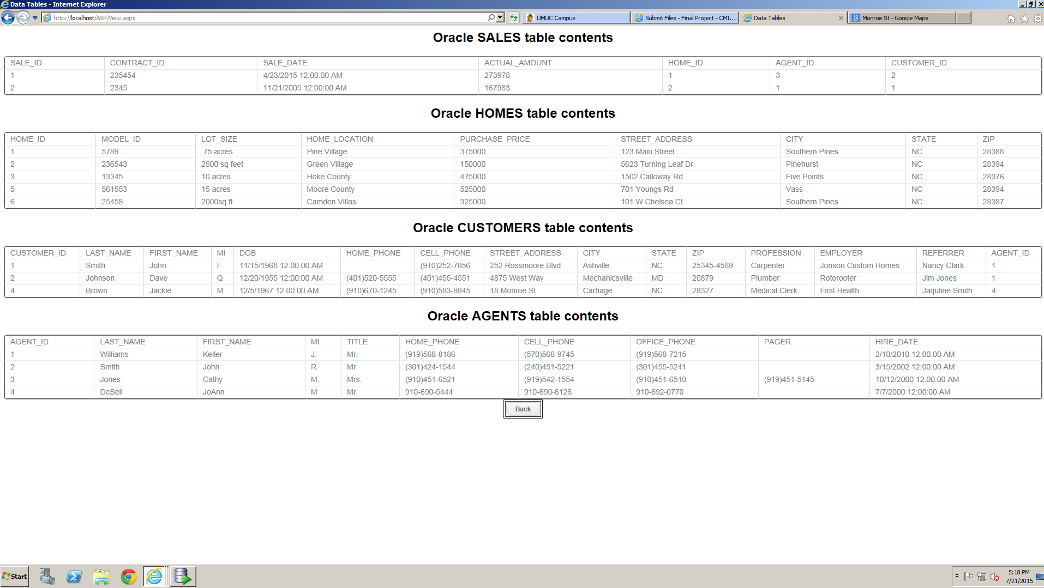

Figure 15 Customer Successfully added to database

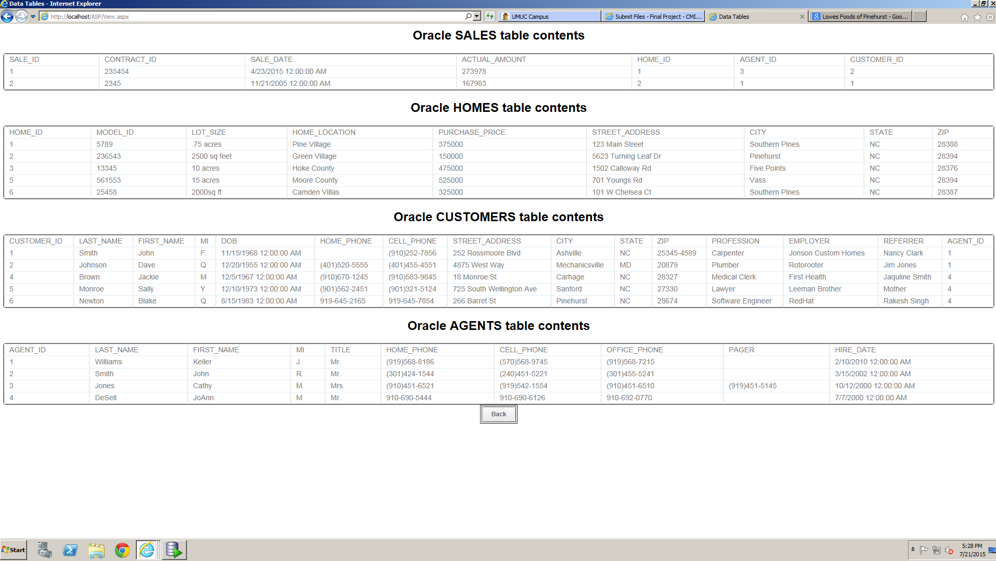

Figure 16 Tables after 3 customers added

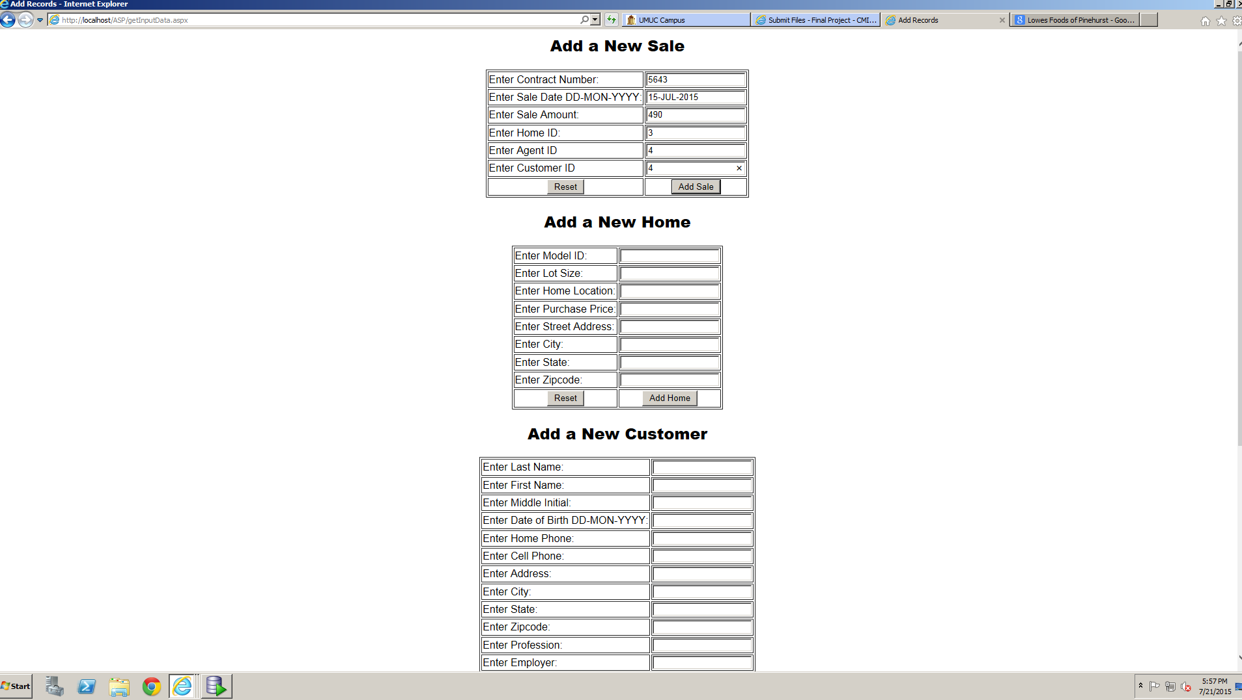

Figure 17 Adding first sale

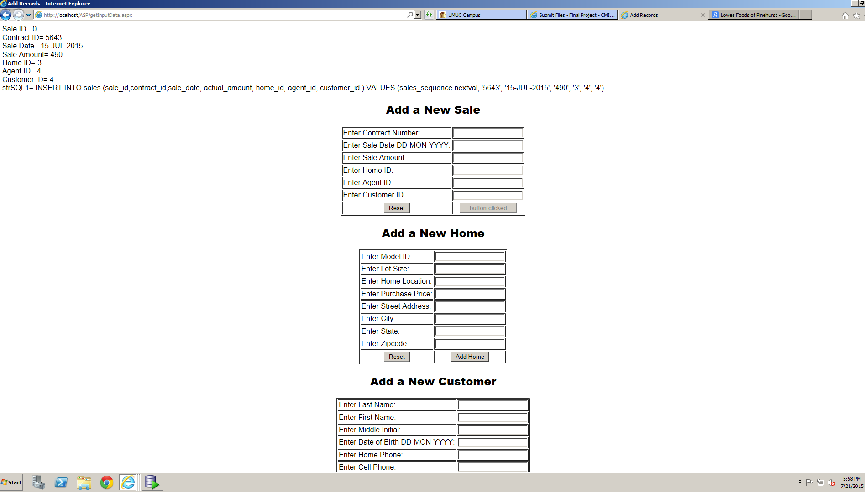

Figure 18 Debugging statements for adding sale successfully displayed

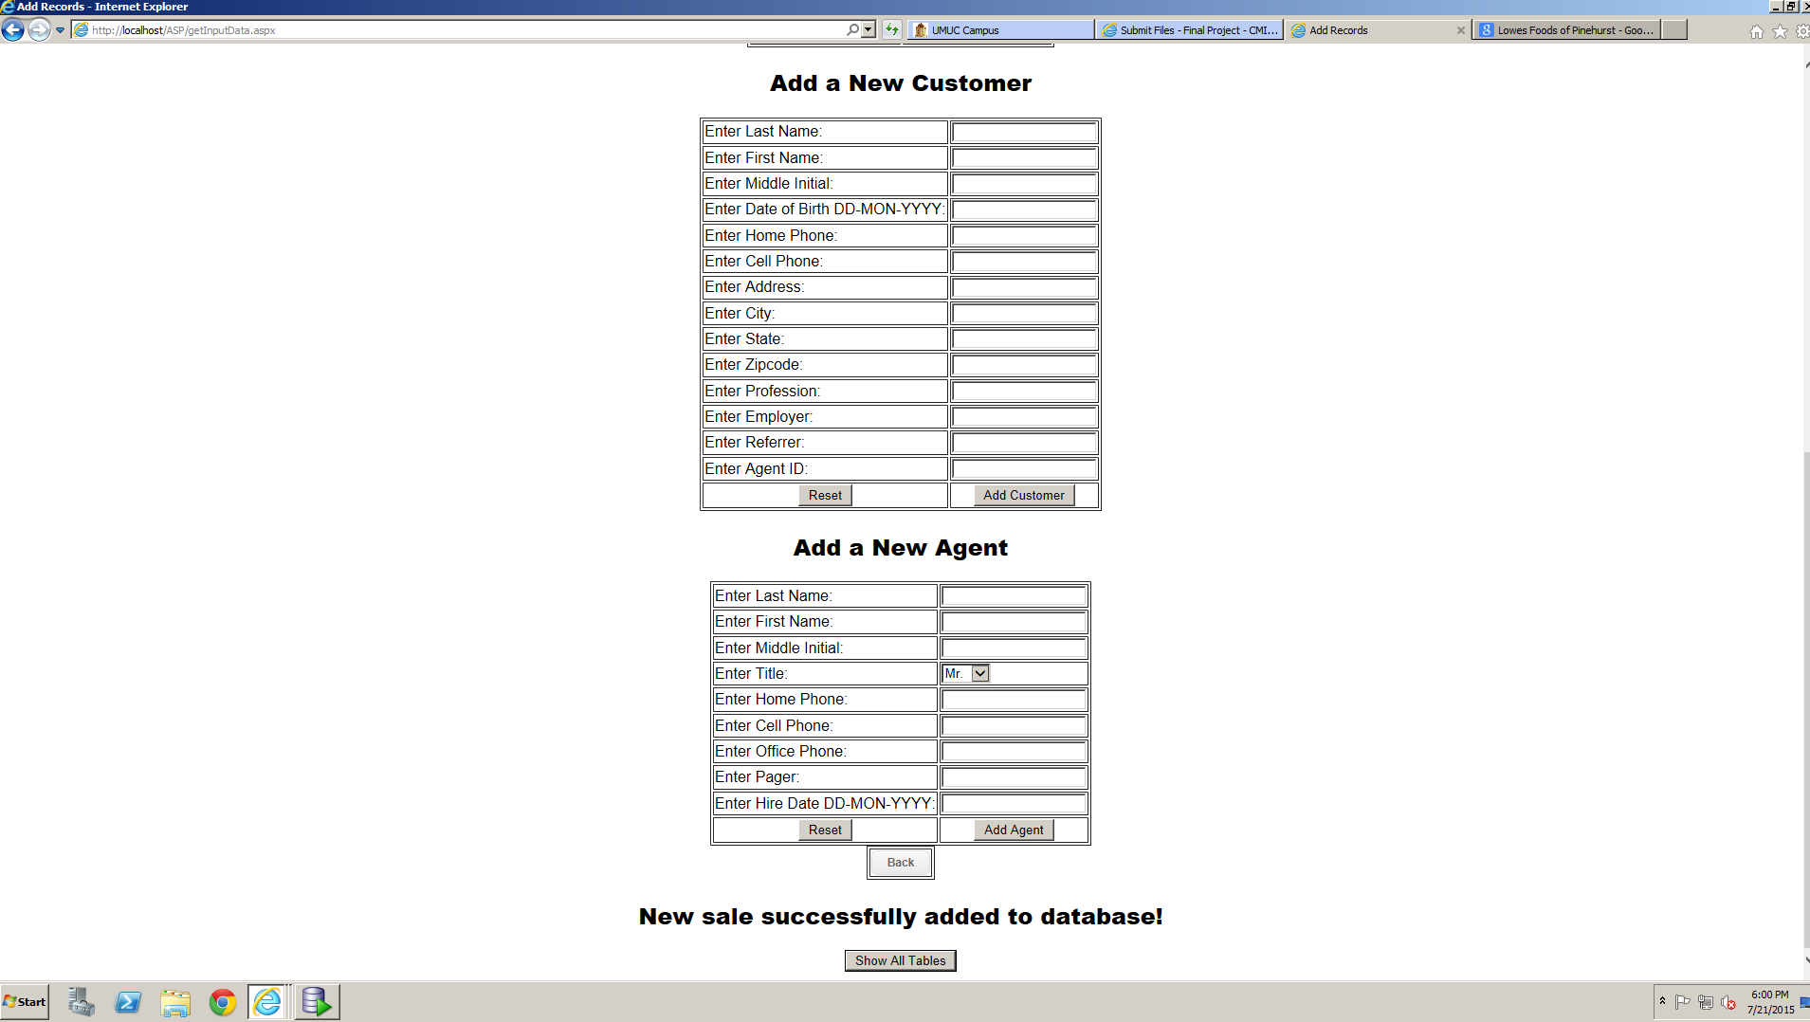

Figure 19 Success message displayed for adding sale

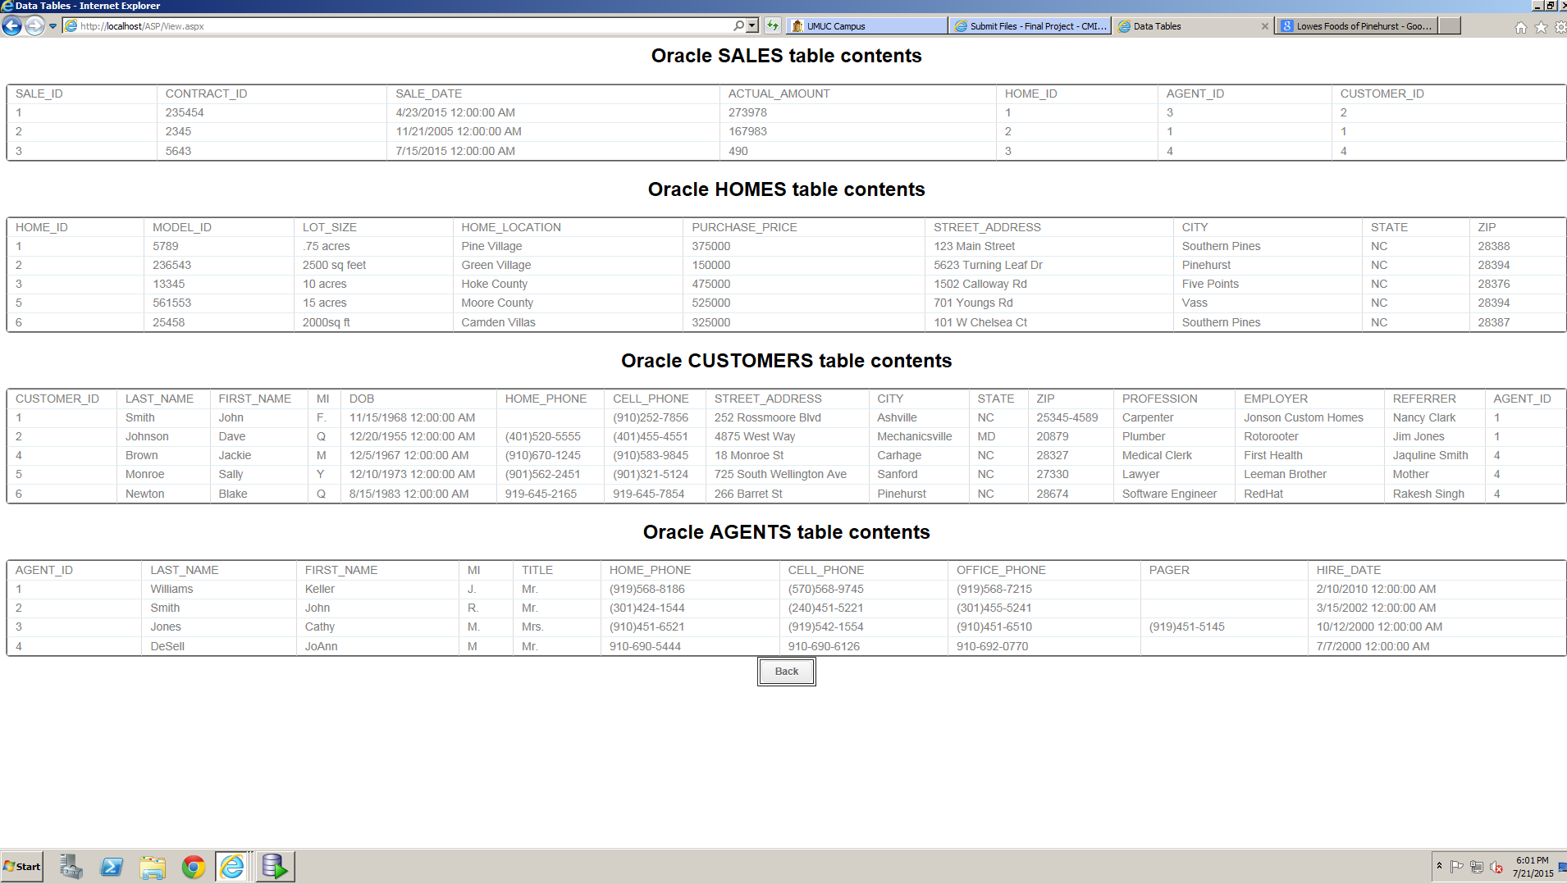

Figure 20 Sales successfully added to database

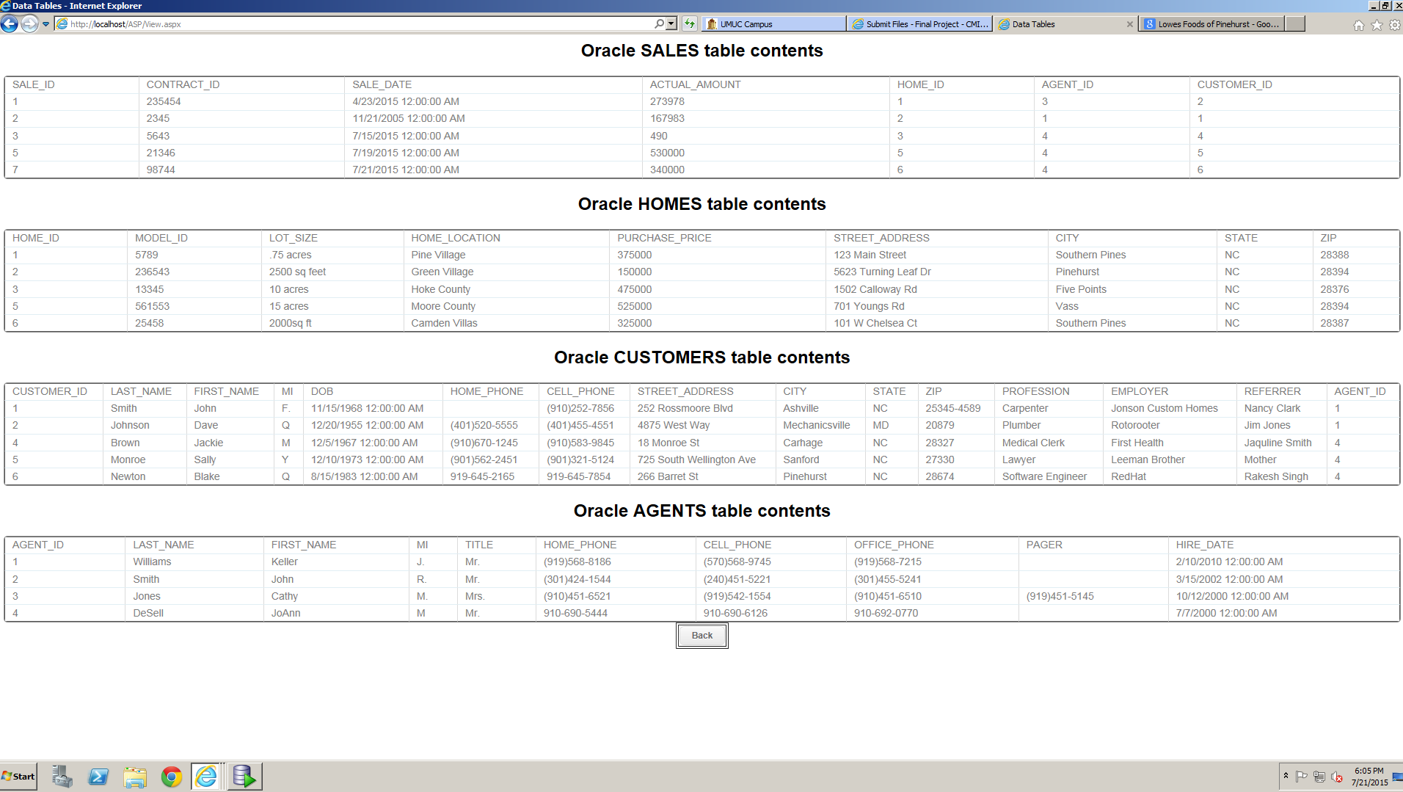

Figure 21 Tables 3 sales added

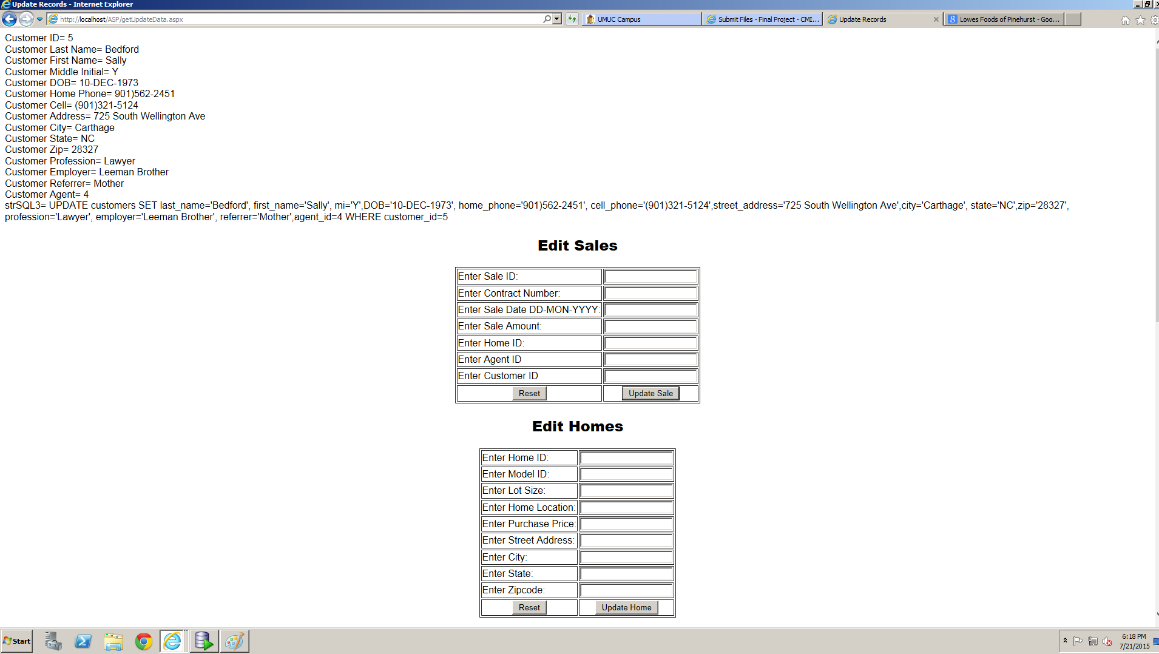

Figure 22 Change customer Monroe last name to Bedford debugging statements displayed

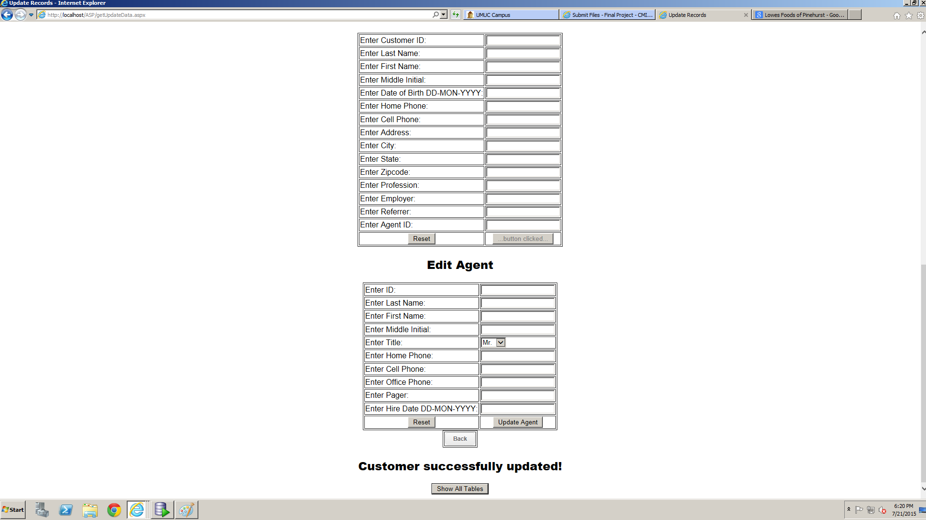

Figure 23 Update success message displayed

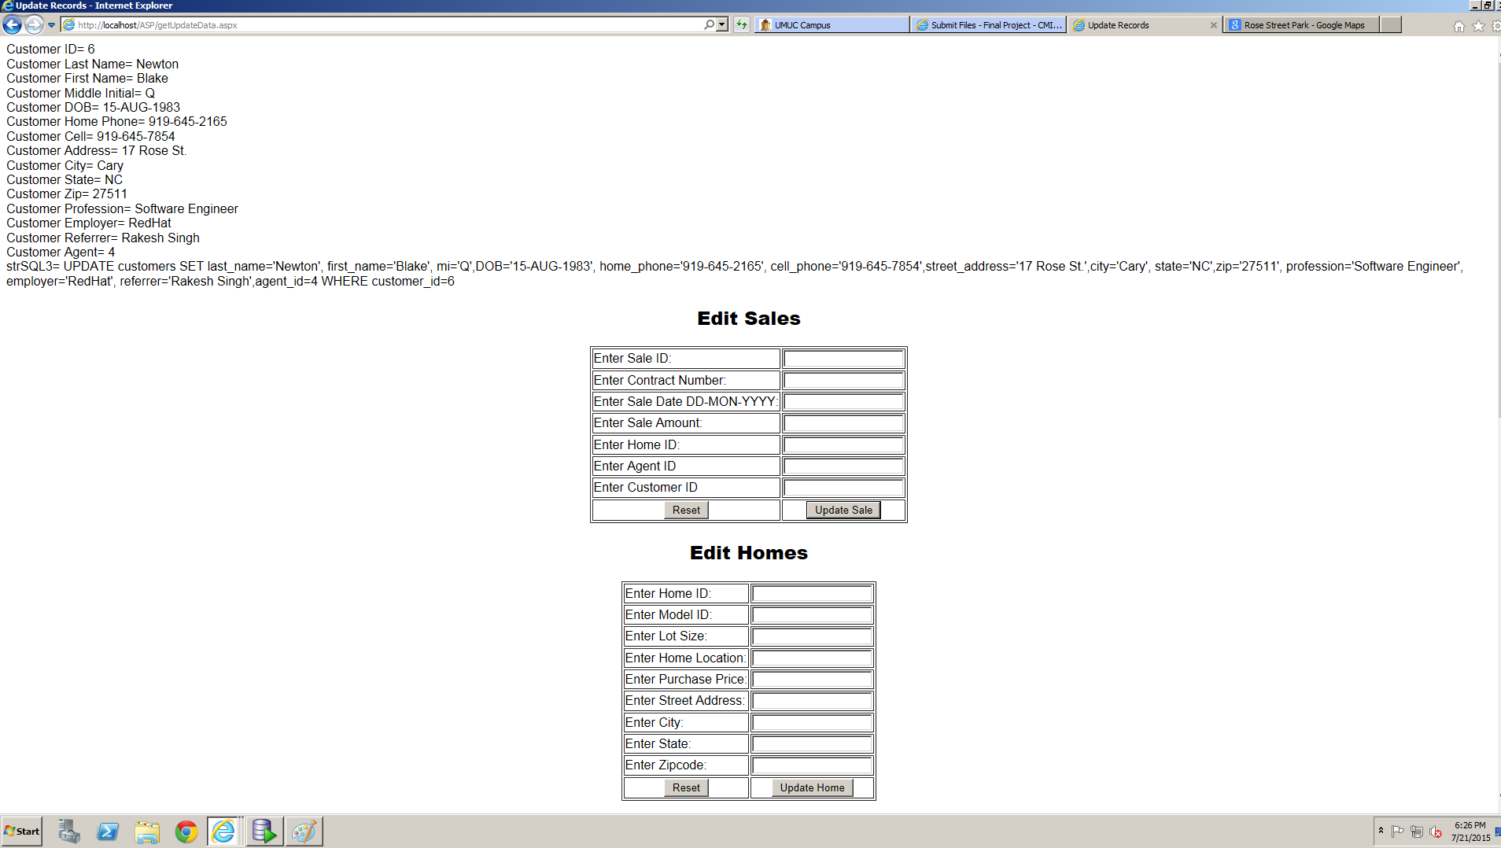

Figure 24 Change customer Newton's address debugging statements successfully displayed

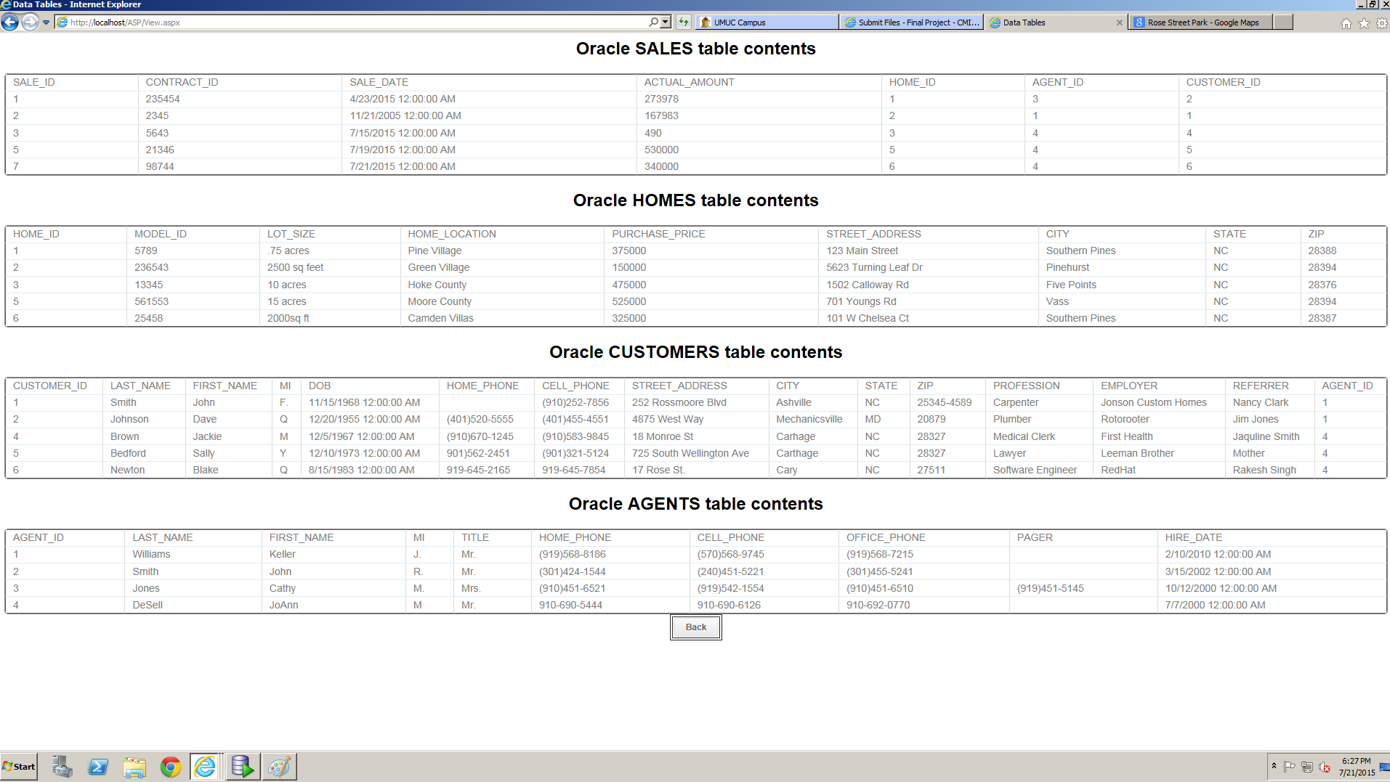

Figure 25 Monroe's last name and Newton's address successfully changed in database

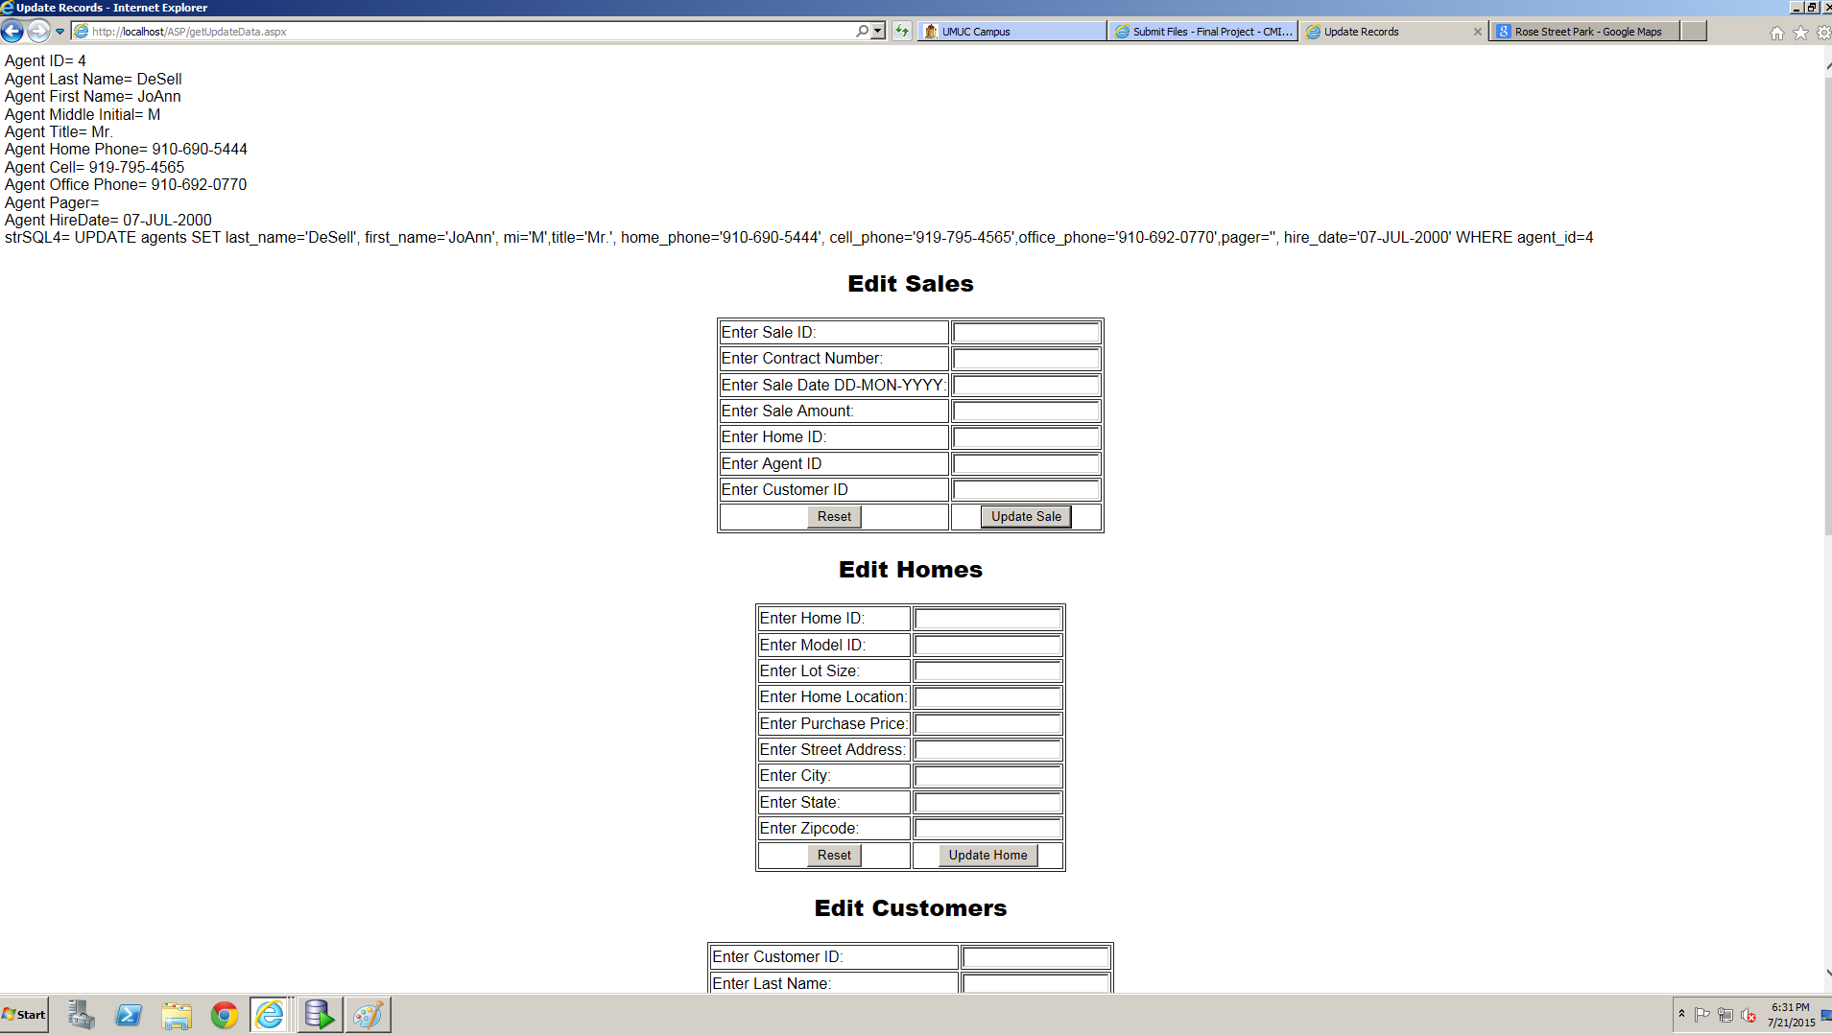

Figure 26 Change Agent DeSell's cell phone number debugging statements successfully displayed

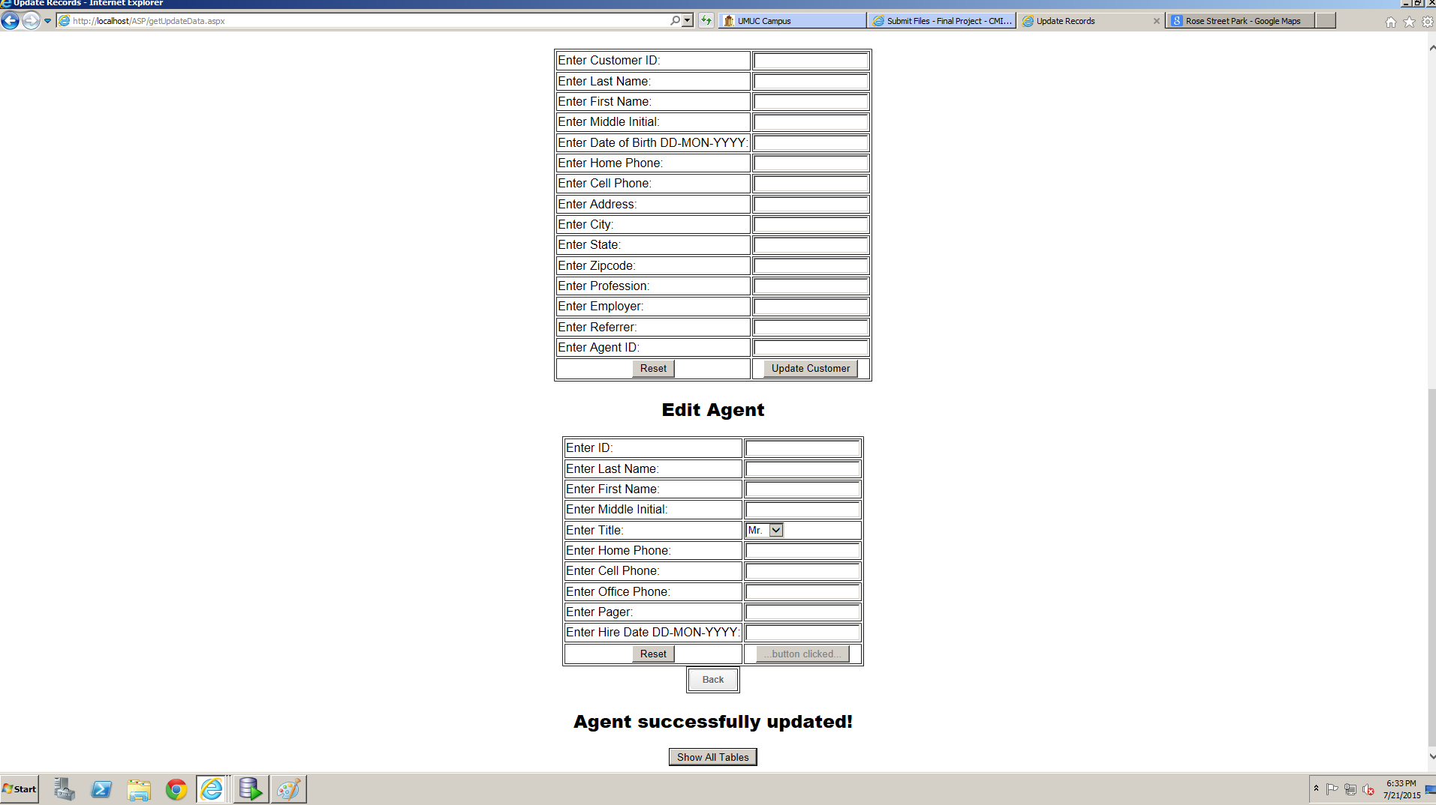

Figure 27 Update success message displayed

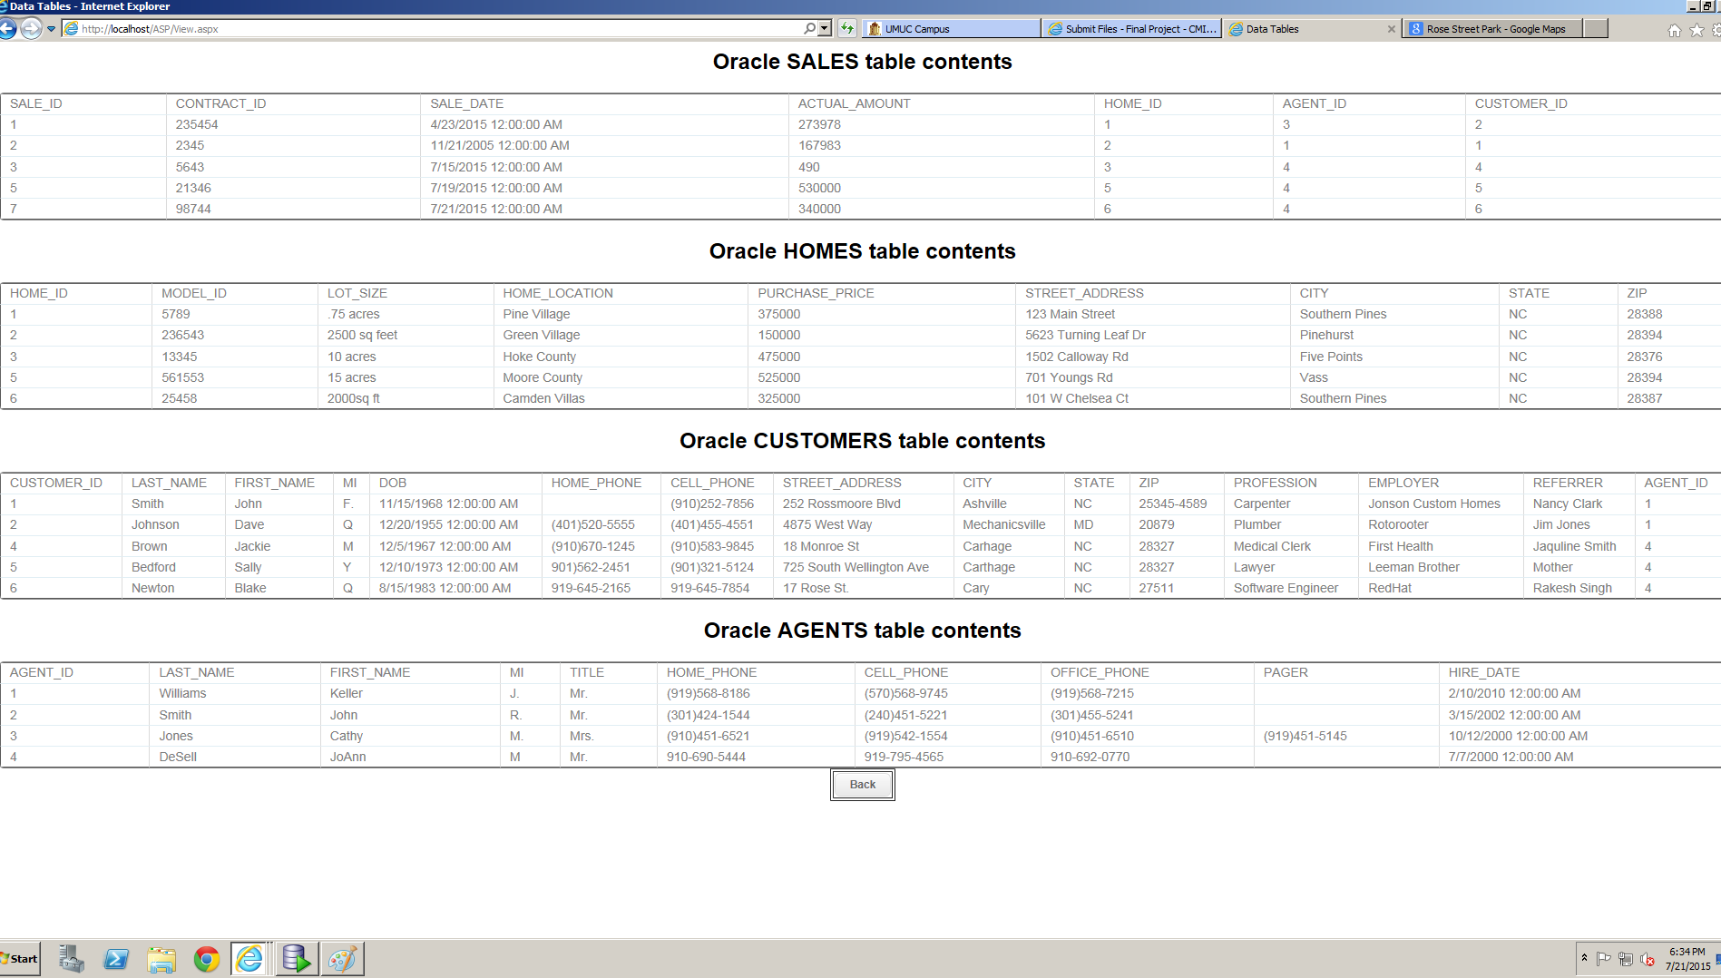

Figure 28 Agent DeSell's cell phone successfully updated

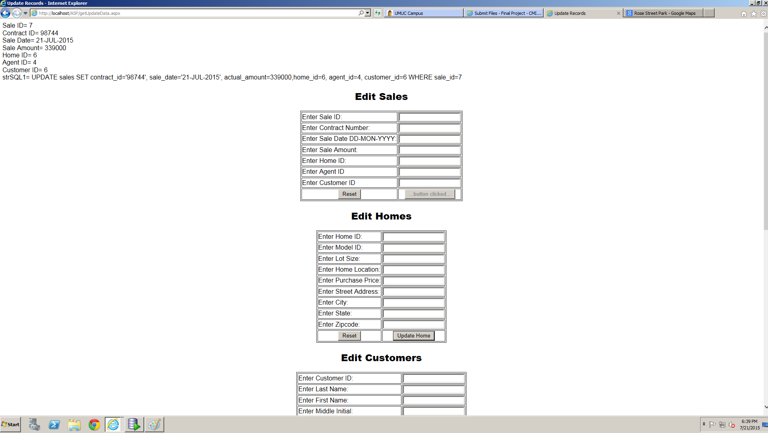

Figure 29 Change the sale price of Home ID 6 debugging messages successfully displayed

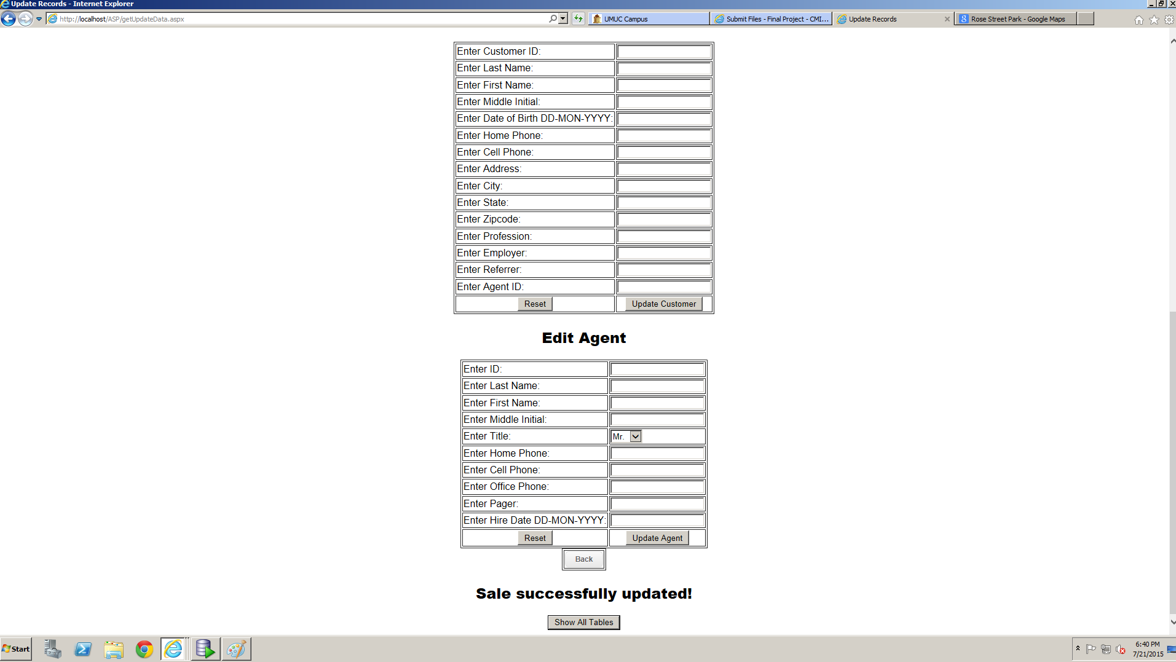

Figure 30 Update success message displayed

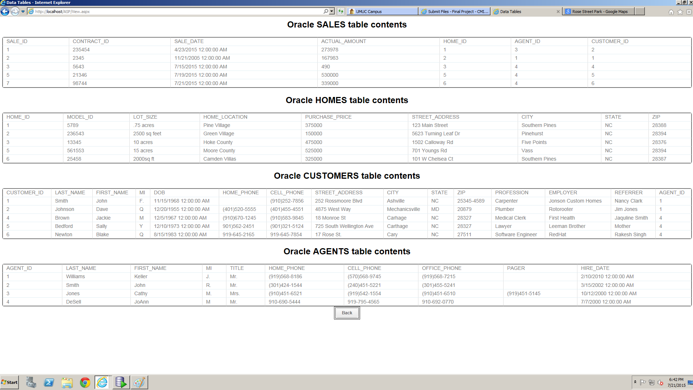

Figure 31 Sale price successfully chaged for Home ID 6 from 340,000 ti 339,000

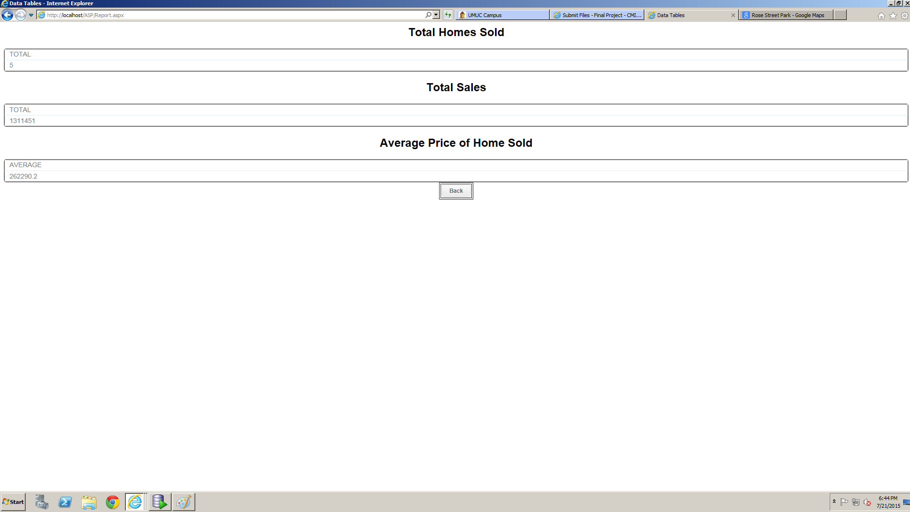

Figure 32Sales report for Reston Real Estate

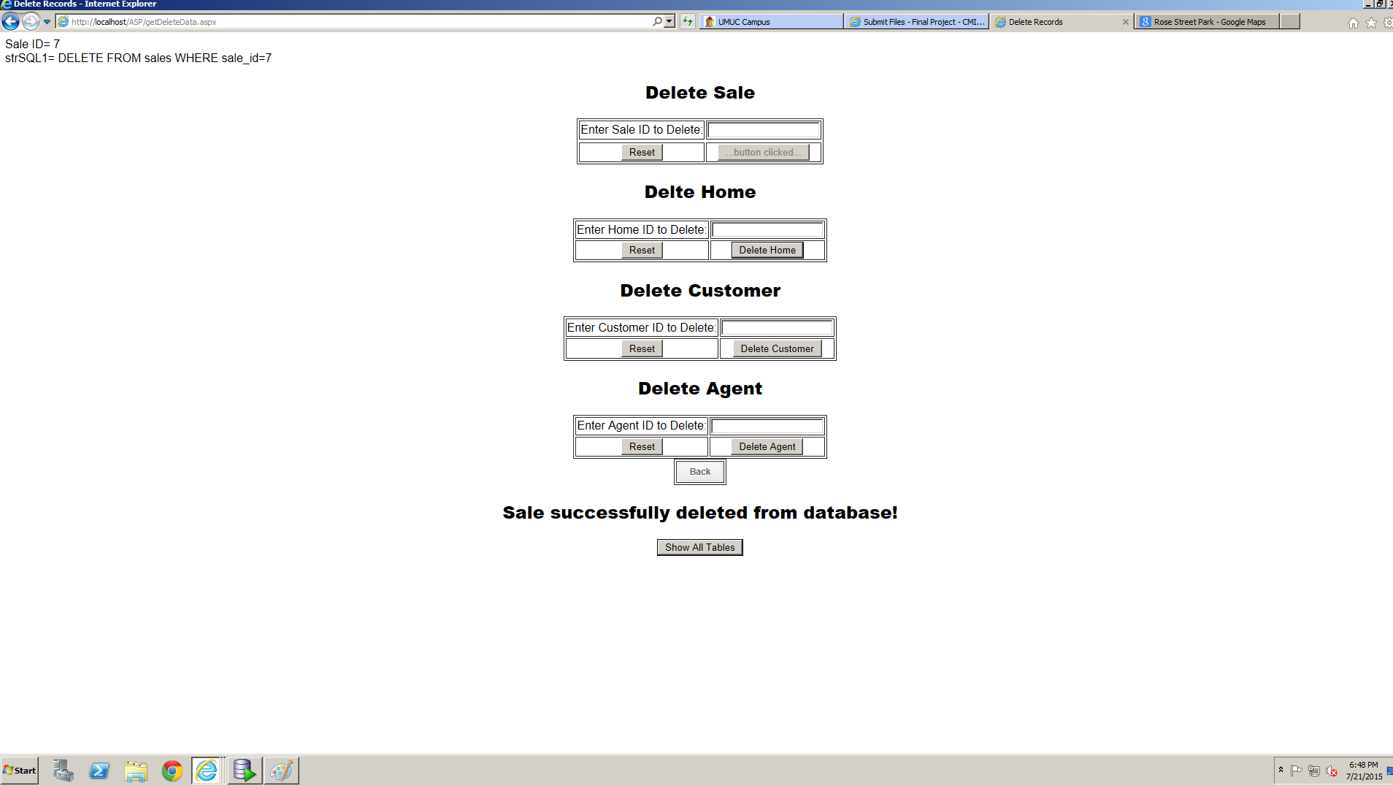

Figure 33 First delete successful

Note: skipped the other success messages to save space.

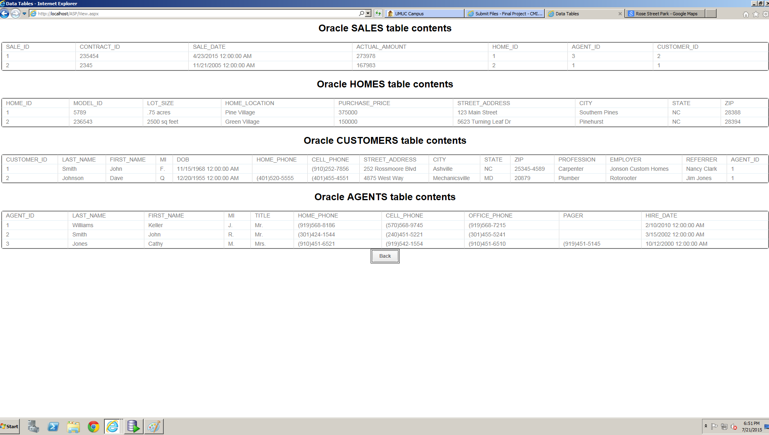

Figure 35 Tables after all deletes